Miquela Gonzales 100919632

Project Plan

I wanted to create a Movie Tracker that keeps a record of movies that the user has watched. The columns in the table are Movie Name, Movie Genre, Release Year, and Review. The Database used to store the movie information is MongoDB. The only way to create a new entry is by authentication. Unauthenticated users will not be able to create new entries to the database, they will only be able to view them.

Home Page view  
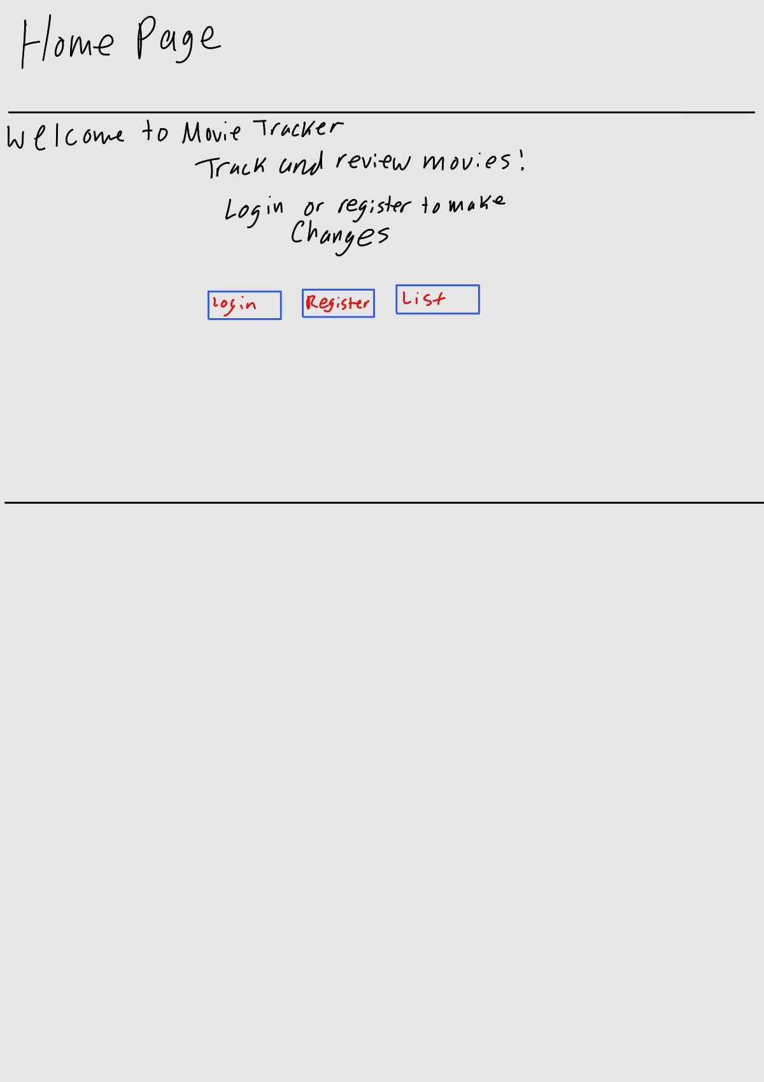

Movie List route view

